BB001 Examination
Duration: 60 minutes Date: Nov 04/2013

Note: Student can use hand note material, do not use your photo document.
Code :____________ Your Name:__________________________________
1. Complete the following cell design based on the following conditions. (20 points )
Ids of a unit width for NMOS is 20uA/um. One contact can flow 50uA/piece.
Metal can flow 20uA/um width. You must design cell which needs current flow of 200uA,
How many contact holes do you need to layout? And which metal width do you draw?
Diffusion Width=200uA/20uA(per um), then width=10um
Idsmax=200uA, then 200uA/50uA(per contact)
→4 contacts for each diffusion.
Metal width 200uA/20uA(per um), then width =10um.

2. Fill the parentheses with the correct words. (60 points , 1 correct word = 4 points)
- A (a: Cell ) is macro or functional unit that performs common operations and is used to build more complex logic blocks.
- A cell library consists of Schematic, (b: Front end library ) and back end library.
- If we analyze most CMOS processes, we find that there are four basic
layer types : (c: conductors ), isolation layers, (d: contacts or vias ), (e: implant ).
- (f: ECO ) needs spare cells if chip layout is not re-designed from the beginning.
- Automatic placement and routing (P&R) technique is used for the layout design of large-scale LSI. The important points of layout design are a power supply design, (g: clock design ) and (h: timing driven design ).
- At (g), the control of the clock skew is indispensable. The clock is a signal that is basic of RTL design based LSI. Because logic gate signals are controlled by clock, if clock skew is insufficient , the violation of timing occurs which results in mal-function of LSI.
- At the step of (h) , the cell placement, routing between cells, resizing of cells and buffer insertion are done to satisfy the timing restriction considered at the logic design.

6. (i: Post Layout Extraction ) means the extraction of wire loads from the layout after P&R.

7. Design rules are the rules that have to be respected when a given design is laid out. There are design rules for all of the components we have been introduced to: polygons, paths, transistors and contacts. Fundamentally, these design rules represent the physical limits of the (j: manufactoring process ). Design rules include : (k: width ) rule, (l: space ) rule, (m: overlap ) rule

-The minimum gate length of a transistor is the prime example of (k) rule.
-(l) rule is applied to avoid an unwanted short circuit between two polygons
-The (m) of a metal layer over a via or contact is a prime example of (o) rule
8. For LSI of deep submicron/nano- technology, signal integrity design/verification is needed. They include phenomena : (1) Power-supply voltage drop, (2) (n: Cross-talk ), (3) electro Migration, (4) (o : Hot Carrier ).
3. Complete the following IC design flow and Layout design flow. Select the correct word from the candidates. (10 points)
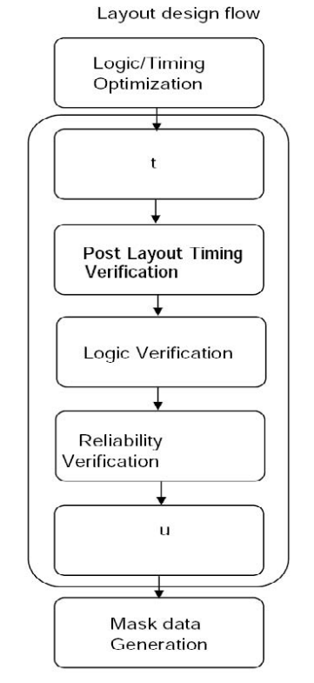
Candidate list
(1) Marketing Idea (2) Mass Production (3) Post Layout Timing Verification
(4) System Simulation/Design (5) Logic /Timing Optimization (6) Circuit Simulation/Design
(7) Layout Design (P&R) (8) Prototype & Testing (9) Reliability Verification
(10) Layout Verification (11) Mask data Generation (12) Architecture definition (13) Logic Verification

Answer :
t :

u :
4. Draw the Layout view (from TOP) of Transistors which have below features: (10 points)
Transistor A : L = 4 um , W = 1 um
Transistor B : L = 1 um , W = 4 um , 2 contact on each Source node and Drain node

